|  |  |
| --- | --- |
| DJCC  Newsletter | **April 2023** |
| Flower accent icon **Important Dates to Remember**  Apr 1 April Fool’s Day  Apr 7 Good Friday/ Paid Holiday  Apr 9 Easter Sunday  Apr 21 Non-Training Day/All Staff training  Apr 22 Earth Day  **Birthday Kids**  **Staff: Students:**  D. Williams-Mitchell C. Barber  C. Burks K. Hibbler  L. Miller D. Holt  L. Macklin J. Johnson  T. Alexander-Lindsey A. Jones  E. Merritt J. McLendon  M. Curry-Banks R. Tedford  O. Glover T. Thompson  S. Bracey  V. Wilson |
| “Success is not final, failure is not fatal: it is the courage to continue that counts.”  Winston Churchill | Flower accent icon, larger Welcome April By: Catera Barber Good day DJCC staff and students!  It’s now officially spring time as of last month so let’s enjoy the sunshine and rain this April will bring.  Look out for the solar eclipse to happen on the 20th of this month, but no need to look in the sky unless you are in Cape Island, Australia (they are the lucky ones in the totality zone).  Wish our basketball team a “Good luck on the game” as you see them throughout the school day.  **And remember, to be the best, you must act the best!** |

|  |
| --- |
| Professional Development    Professional development is a never-ending skill that everyone should work on every day. Professional development entails but is not limited to earning credentials, keeping credentials, attending conferences, and informal learning opportunities. Gaining and maintaining skills earned through practicing professional development certainly ensure success in the workplace. |
| Flower accent icon on second page **Interview with Mrs. Arnell** By: Camron Ramsey   **How important is it for the company to ensure their new employees have the necessary credentials before hiring?**  It is extremely important for new employees, particularly those who require special licensing, to have the necessary credentials before hiring to ensure they are qualified to perform their specific duties as assigned. However, there are times when some credentials are specific to the workplace. In these cases, required credentials may have to be earned on the job.  **Tell me about a time you had to train someone on your team?**  There was a time when I was training a new co-worker on a program we used. Because I did not know the individual well, but wanted them to feel comfortable in the learning space, I created a variety of conceptual learning tools. Turned out she was what I call a combo-learner. She appreciated that she was able to have a variety of ways to get a better grasp on all the information being shared.  **If your manager asks you to complete or do a task/project and you don’t know how to do it, what do you do?**  If I am asked to complete a project or task that I do not know how to do, the first thing I do is ask others if they have ever done anything similar. There is nothing wrong with asking for help. The key is being comfortable enough to ask, and then being humble enough to accept their assistance. When asking for help from others, you might be surprised by who knows what based on their background and experience. If there isn’t anyone else on the team who knows, the internet can be a great tool to provide information on how best to handle tasks and projects.  **What do you think is an area you need to keep growing in professionally?**  The area that I need to continue to grow in professionally best relates to employee relations. In today’s workforce, there are five generations working together. Based on several factors and reasons, every generation has different thoughts and ideals, different expectations, different motivators, and different wants and needs as employees, among a variety of other generational differences. It is important for me to continually grow with the mindset of understanding this and sharing what I know with others to help everyone work more harmoniously together. |

|  |  |
| --- | --- |
| Congratulation to our Graduates:  Fadi Abdullah GPA: 3.61  Camron Ramsey OA completer  Faizon Beal OA Completer    BY: Terri Arnell  -On behalf of Kevin Haynes  Source: <https://www.tonyrobbins.com/productivity-performance/renew-yourself/> | Detroit Job Corps Center  * In 1994, the former Metropolitan Hospital was converted   into the Detroit Job Corps Center replacing the old center   * Located in the northern Detroit, Michigan, just a short drive from downtown * A tuition-free training and education program that connects eligible young men and women with the skills and educational opportunities * DeMarkus Hill and Trevious Perrin are just couple of students taking advantages of these opportunities; recently they passed their road test and became a proud holders of the Michigan driving license.   Thank you, Mr. Bason!!!      Message from the Corner Office  Hello Bear Nation!  Spring is upon us, with longer days and warmer temperatures. Spring is when nature renews itself. When it comes alive with new growth, and where its purpose of beauty is seen all around. It is also a time for us to renew our goals and intentions in our lives. According to Tony Robbins, the nation's top life and business strategist, there are numerous ways to find fulfillment in life and embrace personal growth.  If you want to give new meaning to everything you do, practice these eleven activities: Give yourself a timeout, improve your self-awareness, build a new blueprint, reveal your purpose, break your patterns, examine your limiting beliefs, transform your habits, surround yourself with good people, practice gratitude, face your fears, and give back.  With these behaviors, we can become more productive and perform at a higher level. We can rediscover our passions, reconnect with our true spirits, and continue to grow with purpose. Allow yourself the opportunity to be (and feel) renewed! |



DJCC Groundhog JOB SHADOW DAY 2/28/2023

 

|  |  |
| --- | --- |
| **Job Corps has participated in GHJSD since 1999. Through job shadowing, students are able to observe firsthand how the skills they learn in the classrooms are used in the workplace.**  **Volunteer mentors are able to provide opportunities to demonstrate on-the-job skills, and highlight their organizations’ businesses to young people who will soon join the workforce. Students also receive greater exposure to new jobs and exciting careers, and are able to expand their network of employers.** |  |
| DJCC Rocks 313 Day | |

March 13th = 313 Day

It’s a day to celebrate the Motor City and its famous area code.

The area code was established in 1947 and serves Wayne County,

including the city of DETROIT.

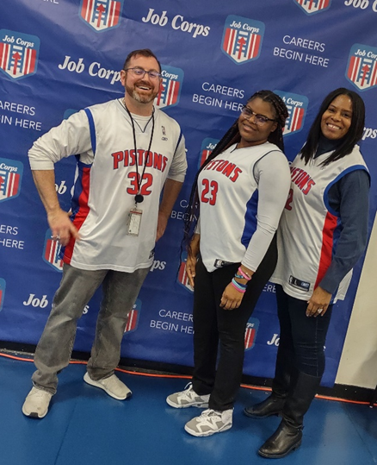

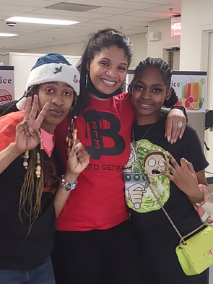

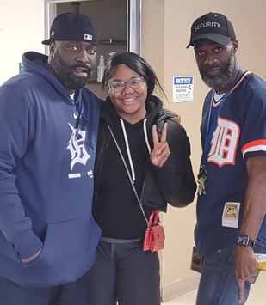



**DJCC**

**313** –852-0300

