THREE MORE NORTH TEXAS JOB CORPS STUDENTS JOIN THE ADVANCED TRAINING RANKS ATTENDING
THE SOLAR PANEL-ADVANCED TRAINING PROGRAM
AT THE GLENMONT JOB CORPS CENTER

Terrence Cross, Jr. is one of those unique Job Corps students. He has attended three Job Corps Centers and is embarking on June 28th to his fourth center, Glenmont Job Corps Center in Glenmont, NY. There he will be enrolled in their Solar-Panel – Advanced Training Program. The previous sites and trainings successfully completed are: Joliet JCC for Office Administration, Gary JCC for Advanced Residential Advisor, and North Texas JCC for the HBI Building Construction Technology.
Terrence is from Milwaukee, WI and states “I enrolled in Job Corps to develop a career plan and to be able to take care of my two year old daughter. The training I received at NTJCC has set me up for life. I earned my certifications and cards. I want to gain solar panel skills, be more independent, and earn an associates degree. I plan to become a master electrician and HVAC tech and own my own international business. The skills I have acquired in Job Corps will take me there.”

Terrence Cross, Jr.

Elijah Lacy is from Irving, TX. He enrolled at the NTJCC on 9/20/2016. He completed Materials Distribution and the HBI Building Construction Technology trade. He learned of Job Corps from his grandmother who had friends that knew of the program. He states that “my trades prepared me in every way possible for the Advanced Training Program. My experience at NTJCC has been great and I plan to gain everything I can from my advanced training. I want to be the top dog in my field.”

Elijah Lacy

Zachary Weisbard or Zac, as he is affectionately known, enrolled at the NTJCC on April 25, 2017. Zac states that he had a full time job before enrolling but the company went out of business. He needed to find something to help himself. “The great opportunity that Job Corps provides is what attracted me to the program.”

Zac completed the Building Construction Technology and Electrical trades at NTJCC. He states that “the Solar Panel training is a combination of these two trades and the just the skills alone from these two will help me to get a great start in this Solar Panel Advanced Training program.”

“My experience at NTJCC has helped me to learn how to work with others, from fun people to those not so fun.” Zac sees a better and brighter future for himself after completing this advanced training. He want to get a job immediately after finishing. His family is excited about where he is headed and the opportunities he will gain as a result.

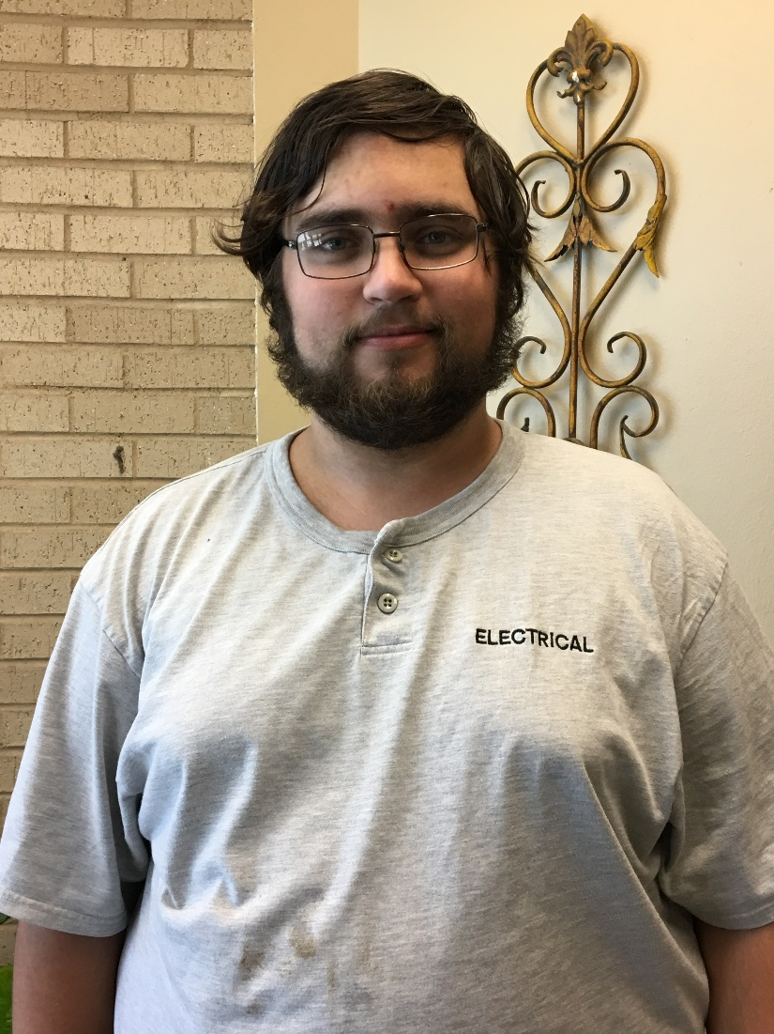
Zachary Weisbard

