Fred G. Acosta Job Corps Center
Tucson, Arizona

Center Director’s Desk 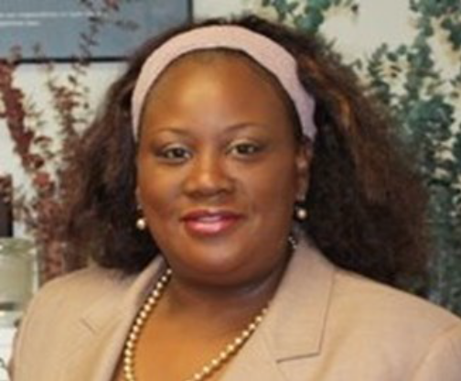
-Carld Rosborough

Fred G Acosta hosted Stand Up For Safety Council Meeting September 28, 2016. There were 18 Law Enforcement member from 10 agencies from Pima County, City of Tucson and other municipalities. The Purpose of this Council is to inform the community and develop relationships with the Law Enforcement agencies. Our additional goal is placement. We had great discussion on:  
- Community Interaction
- Training Site & recruitment
- “Dangerous Encounter/Active Shooter”
- “Legalizing recreational use of Marijuana”
- “Human Trafficking”
- “Spice, opioid, E-cigarette”
Additionally on Friday September 30, 2016. Pictured with United States Congress-woman Martha McSally, I received the FBI Silver Award for Community Service. It is awarded to agencies and individuals for their efforts to promote safety and community inclusion. This is the third year in a row we have been so honored.


A RAY OF SUNSHINE!
Meet Karen Peralta a young lady with a promising and bright future. Karen is a former CNA Student here at Fred G. Acosta. Karen entered the CNA program in April and completed her training in August.
Its no wonder she was such a fast completer with her winning attitude. Her smile lights up a room and she has a wonderful positive outlook, full of caring and compassion. Karen worked attentively and quickly to finish her vocation. She studied hard and it paid off.
Its obvious she chose the perfect vocation for alignment with her values. Karen successfully accomplished her goal of being awarded her License and getting a job in her vocation. She is the kind of person I would want taking care of my loved ones. Karen is working at Villa Campana full time in a job training match. I’m sure she is now lighting up the room of all the patients under her care.
-Marcia West

